Curriculum Coverage and Progression Map Guidance
Contents

Primary Science Programme of Study | 3
EYFS Framework | 10
Suggested Teaching Order – Long-Term Plan | 11
Working Scientifically | 13
PlanIt Science Working Scientifically Skills Progression | 16
PlanIt Science Progression Map Year 1–6 Spreadsheet Guidance | 27

Primary Science Programme of Study Coverage

 |  | Year 1 | Year 2 | Year 3 | Year 4 | Year 5 | Year 6
Biology | Animals Including Humans | Animals Including Humans | Animals Including Humans | Animals Including Humans | Animals Including Humans | Animals Including Humans | Animals Including Humans
Biology | Plants | Plants | Plants | Plants
Biology | Living Things and Their Habitats |  | Living Things and Their Habitats |  | Living Things and Their Habitats | Living Things and Their Habitats | Living Things and Their Habitats
Biology | Evolution and Inheritance |  |  |  |  |  | Evolution and Inheritance
Chemistry | Materials | Everyday Materials | Uses of Everyday Materials | Rocks | States of Matter | Properties and Changes of Materials
Physics | Seasonal Changes | Seasonal Changes
Physics | Forces |  |  | Forces and Magnets |  | Forces
Physics | Light |  |  | Light |  |  | Light
Physics | Electricity |  |  |  | Electricity |  | Electricity
Physics | Sound |  |  |  | Sound
Physics | Earth and Space |  |  |  |  | Earth and Space
Sustainability  (supplementary PlanIt Science units) |  | Nature Protectors | Biodiversity – Minibeasts | Biodiversity – Birds | Reduce, Reuse, Recycle | Changing Oceans | Changing Climate
Scientists and Inventors (supplementary PlanIt Science units) |  | Scientists and Inventors | Scientists and Inventors | Scientists and Inventors | Scientists and Inventors | Scientists and Inventors | Scientists and Inventors

Primary Science Programme of Study Progression

Biology | Animals Including Humans
Biology | Year 1 | Pupils should be taught to:  - identify and name a variety of common animals including fish, amphibians, reptiles, birds and mammals;  - identify and name a variety of common animals that are carnivores, herbivores and omnivores;  - describe and compare the structure of a variety of common animals (fish, amphibians, reptiles, birds and mammals including pets);  - identify, name, draw and label the basic parts of the human body and say which part of the body is associated with each sense.
Biology | Year 2 | Pupils should be taught to:  - notice that animals, including humans, have offspring which grow into adults;  - find out about and describe the basic needs of animals, including humans, for survival (water, food and air);  - describe the importance for humans of exercise, eating the right amounts of different types of food, and hygiene.
Biology | Year 3 | Pupils should be taught to:  - identify that animals, including humans, need the right types and amount of nutrition, and that they cannot make their own food; they get nutrition from what they eat;  - identify that humans and some other animals have skeletons and muscles for support, protection and movement.
Biology | Year 4 | Pupils should be taught to:  - describe the simple functions of the basic parts of the digestive system in humans;  - identify the different types of teeth in humans and their simple functions;  - construct and interpret a variety of food chains, identifying producers, predators and prey.
Biology | Year 5 | Pupils should be taught to:  - describe the changes as humans develop to old age.
Biology | Year 6 | Pupils should be taught to:  - identify and name the main parts of the human circulatory system, and describe the functions of the heart, blood vessels and blood;  - recognise the impact of diet, exercise, drugs and lifestyle on the way their bodies function;  - describe the ways in which nutrients and water are transported within animals, including humans.

Primary Science Programme of Study Progression

Biology | Plants
Biology | Year 1 | Pupils should be taught to:  - identify and name a variety of common wild and garden plants, including deciduous and evergreen trees;  - identify and describe the basic structure of a variety of common flowering plants, including trees.
Biology | Year 2 | Pupils should be taught to:  - observe and describe how seeds and bulbs grow into mature plants;  - find out and describe how plants need water, light and a suitable temperature to grow and stay healthy.
Biology | Year 3 | Pupils should be taught to:  - identify and describe the functions of different parts of flowering plants: roots, stem/trunk, leaves and flowers;  - explore the requirements of plants for life and growth (air, light, water, nutrients from soil, and room to grow) and how they vary from plant to plant;  - investigate the way in which water is transported within plants;  - explore the part that flowers play in the life cycle of flowering plants, including pollination, seed formation and seed dispersal.
Biology | Living Things and Their Habitats
Biology | Year 2 | Pupils should be taught to:  - explore and compare the differences between things that are living, dead, and things that have never been alive;  - identify that most living things live in habitats to which they are suited and describe how different habitats provide for the basic needs of different kinds of animals and plants, and how they depend on each other;  - identify and name a variety of plants and animals in their habitats, including microhabitats;  - describe how animals obtain their food from plants and other animals, using the idea of a simple food chain, and identify and name different sources of food.
Biology | Year 4 | Pupils should be taught to:  - recognise that living things can be grouped in a variety of ways;  - explore and use classification keys to help group, identify and name a variety of living things in their local and wider environment;  - recognise that environments can change and that this can sometimes pose dangers to living things.
Biology | Year 5 | Pupils should be taught to:  - describe the differences in the life cycles of a mammal, an amphibian, an insect and a bird;  - describe the life process of reproduction in some plants and animals.
Biology | Year 6 | Pupils should be taught to:  - describe how living things are classified into broad groups according to common observable characteristics and based on similarities and differences, including micro-organisms, plants and animals;  - give reasons for classifying plants and animals based on specific characteristics.

Primary Science Programme of Study Progression

Biology | Evolution and Inheritance
Biology | Year 6 | Pupils should be taught to:  - recognise that living things have changed over time and that fossils provide information about living things that inhabited the Earth millions of years ago;  - recognise that living things produce offspring of the same kind, but normally offspring vary and are not identical to their parents;  - identify how animals and plants are adapted to suit their environment in different ways and that adaptation may lead to evolution.

Primary Science Programme of Study Progression

Chemistry | Materials
Chemistry | Year 1 –  Everyday Materials | Pupils should be taught to:  - distinguish between an object and the material from which it is made;  - identify and name a variety of everyday materials, including wood, plastic, glass, metal, water, and rock;  - describe the simple physical properties of a variety of everyday materials;  - compare and group together a variety of everyday materials on the basis of their simple physical properties.
Chemistry | Year 2 – Uses of Everyday Materials | Pupils should be taught to:  - identify and compare the suitability of a variety of everyday materials, including wood, metal, plastic, glass, brick, rock, paper and cardboard for particular uses;  - find out how the shapes of solid objects made from some materials can be changed by squashing, bending, twisting and stretching.
Chemistry | Year 3 – Rocks | Pupils should be taught to:  - compare and group together different kinds of rocks on the basis of their appearance and simple physical properties;  - describe in simple terms how fossils are formed when things that have lived are trapped within rock;  - recognise that soils are made from rocks and organic matter.
Chemistry | Year 4 – States of Matter | Pupils should be taught to:  - compare and group materials together, according to whether they are solids, liquids or gases;  - observe that some materials change state when they are heated or cooled, and measure or research the temperature at which this happens in degrees Celsius (°C);  - identify the part played by evaporation and condensation in the water cycle and associate the rate of evaporation with temperature.
Chemistry | Year 5 – Properties and Changes of Materials | Pupils should be taught to:  - compare and group together everyday materials on the basis of their properties, including their hardness, solubility, transparency, conductivity (electrical and thermal), and response to magnets;  - know that some materials will dissolve in liquid to form a solution, and describe how to recover a substance from a solution;  - use knowledge of solids, liquids and gases to decide how mixtures might be separated, including through filtering, sieving and evaporating;  - give reasons, based on evidence from comparative and fair tests, for the particular uses of everyday materials, including metals, wood and plastic;  - demonstrate that dissolving, mixing and changes of state are reversible changes;  - explain that some changes result in the formation of new materials, and that this kind of change is not usually reversible, including changes associated with burning and the action of acid on bicarbonate of soda.

Primary Science Programme of Study Progression

Physics | Seasonal Changes
Physics | Year 1 | Pupils should be taught to:  - observe changes across the 4 seasons;  - observe and describe weather associated with the seasons and how day length varies.
Physics | Light
Physics | Year 3 | Pupils should be taught to:  - recognise that they need light in order to see things and that dark is the absence of light;  - notice that light is reflected from surfaces;  - recognise that light from the sun can be dangerous and that there are ways to protect their eyes;  - recognise that shadows are formed when the light from a light source is blocked by an opaque object;  - find patterns in the way that the size of shadows change.
Physics | Year 6 | Pupils should be taught to:  - recognise that light appears to travel in straight lines;  - use the idea that light travels in straight lines to explain that objects are seen because they give out or reflect light into the eye;  - explain that we see things because light travels from light sources to our eyes or from light sources to objects and then to our eyes;  - use the idea that light travels in straight lines to explain why shadows have the same shape as the objects that cast them.
Physics | Forces
Physics | Year 3– Forces and Magnets | Pupils should be taught to:  - compare how things move on different surfaces;  - notice that some forces need contact between 2 objects, but magnetic forces can act at a distance;  - observe how magnets attract or repel each other and attract some materials and not others;  - compare and group together a variety of everyday materials on the basis of whether they are attracted to a magnet, and identify some magnetic materials;  - describe magnets as having 2 poles;  - predict whether 2 magnets will attract or repel each other, depending on which poles are facing.
Physics | Year 5 – Forces | Pupils should be taught to:  - explain that unsupported objects fall towards the Earth because of the force of gravity acting between the Earth and the falling object;  - identify the effects of air resistance, water resistance and friction, that act between moving surfaces;  - recognise that some mechanisms including levers, pulleys and gears allow a smaller force to have a greater effect.

Primary Science Programme of Study Progression

Physics | Electricity
Physics | Year 4 | Pupils should be taught to:  - identify common appliances that run on electricity;  - construct a simple series electrical circuit, identifying and naming its basic parts, including cells, wires, bulbs, switches and buzzers;  - identify whether or not a lamp will light in a simple series circuit, based on whether or not the lamp is part of a complete loop with a battery;  - recognise that a switch opens and closes a circuit and associate this with whether or not a lamp lights in a simple series circuit;  - recognise some common conductors and insulators, and associate metals with being good conductors.
Physics | Year 6 | Pupils should be taught to:  - associate the brightness of a lamp or the volume of a buzzer with the number and voltage of cells used in the circuit;  - compare and give reasons for variations in how components function, including the brightness of bulbs, the loudness of buzzers and the on/off position of switches;  - use recognised symbols when representing a simple circuit in a diagram.
Physics | Sound
Physics | Year 4 | Pupils should be taught to:  - identify how sounds are made, associating some of them with something vibrating;  - recognise that vibrations from sounds travel through a medium to the ear;  - find patterns between the pitch of a sound and features of the object that produced it;  - find patterns between the volume of a sound and the strength of the vibrations that produced it;  - recognise that sounds get fainter as the distance from the sound source increases.
Physics | Earth and Space
Physics | Year 5 | Pupils should be taught to:  - describe the movement of the Earth and other planets relative to the sun in the solar system;  - describe the movement of the moon relative to the Earth;  - describe the sun, Earth and moon as approximately spherical bodies;  - use the idea of the Earth’s rotation to explain day and night and the apparent movement of the sun across the sky.

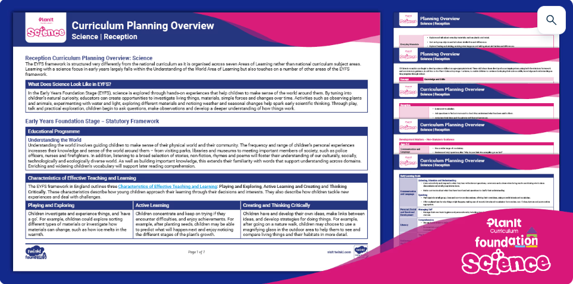
In the Early Years Foundation Stage (EYFS), science is explored through hands-on experiences that help children to make sense of the world around them. By tuning in to children’s natural curiosity, educators can create opportunities to investigate living things, materials, simple forces and changes over time. Activities such as observing plants and animals, experimenting with water and light, exploring different materials, and noticing weather and seasonal changes help spark early scientific thinking. Through play, talk and practical exploration, children begin to ask questions, make observations and develop a deeper understanding of how things work.
We have considered the relevant statements from the EYFS Framework that feed into the science programme of study in order to aid the progression of learning between EYFS and KS1. For more detail about linked subject progression within the EYFS Framework, please refer to the Reception Curriculum Planning Overview: PlanIt Science.
EYFS Framework

Provided on the next page is an overview of the suggested order of teaching for the PlanIt Science units across years 1–6. For a more detailed rationale behind the sequencing of PlanIt Science, see the PlanIt Science Principles, Progression and Curriculum Design.
The order of teaching has been based upon the aim to build substantive and disciplinary knowledge within the year and across year groups and to take advantage of the best time of year to observe the natural environment. It is recommended that units are taught in the suggested order. Each unit has been carefully planned with progression of vocabulary and prior knowledge taken into consideration.
The Scientists and Inventors lessons can be taught as a whole unit or lessons can be taught individually throughout the year alongside the corresponding unit. These lessons can be used to secure knowledge during a unit, to study the works of scientists linked to a unit, to tie in with science events or to retrieve knowledge of a topic area. Our Scientists and Inventors units help to celebrate the contributions of the global scientific community throughout history. We aim to strengthen representation and ensure all children see science as relevant and accessible by introducing diverse scientific figures and contributions.
Suggested Teaching Order
*New S&I content coming soon.
Long-Term Plan
 | Autumn 1 | Autumn 2 | Spring 1 | Spring 2 | Summer 1 | Summer 2
Year 1 | Animals Including Humans | Seasonal Changes (Autumn and Winter) | Everyday Materials | Seasonal Changes (Spring and Summer) | Plants | Nature Protectors
S&I | Dr Linda B Buck* | Anna Mani* | Dr Lonnie Johnson* | Anna Mani* | John Grimshaw Wilkinson* | Isatou Ceesay*
Year 2 | Living Things and Their Habitats | Animals Including Humans | Uses of Everyday Materials | Plants | Biodiversity – Minibeasts | Consolidation
S&I | Dr Roseli  Ocampo-Friedmann* | Dr Elsie Widdowson* | Harry Brearley* | Dr Janaki Ammal | Dr Geerat Vermeij* | Consolidation
Year 3 | Rocks | Animals Including Humans | Forces and Magnets | Plants | Light | Biodiversity – Birds
S&I | Dr Marguerite Thomas Williams* | Dr Marie Curie* | Dr Masato Sagawa* | George  Washington-Carver* | Professor Shuji Nakamura* | Biodiversity – Birds
Year 4 | Living Things and Their Habitats | Animals Including Humans | Electricity | States of Matter | Sound | Reduce, Reuse, Recycle
S&I | Lesein Mutunkei* | Dr Krithi Karanth* | Sir Tim Berners-Lee* | Kiara Nirghin* | Professor Sophie Scott* | Reduce, Reuse, Recycle
Year 5 | Properties and Changes of Materials | Forces | Earth and Space | Animals Including Humans | Living Things and Their Habitats | Changing Oceans
S&I | Dr Ruth Benerito | William Kamkwamba | John McFall | Professor Hayat Sindi | Dr Ayana Johnson | Dr Emma Camp
Year 6 | Living Things and Their Habitats | Animals Including Humans | Light | Electricity | Evolution and Inheritance | Changing Climate  (coming soon)
S&I | Tu Youyou | Dr Daniel Hale Williams | Dr Johann Heinrich Schulze | Edith Clarke | Rachel Carson | Changing Climate  (coming soon)

The national curriculum science programme of study explains how ‘working scientifically’ skills might be taught by embedding them within topics and as a key feature of scientific enquiry. Working scientifically develops the disciplinary knowledge needed to embed the required methods and processes used to explore and investigate the substantive programme of study aims. The below table shows the statutory working scientifically aims.
Working Scientifically
KS1 | LKS2 | UKS2
- asking simple questions and recognising that they can be answered in different ways  - observing closely, using simple equipment  - performing simple tests  - identifying and classifying  - using their observations and ideas to suggest answers to questions  - gathering and recording data to help in answering questions | - asking relevant questions and using different types of scientific enquiries to answer them  - setting up simple practical enquiries, comparative and fair tests  - making systematic and careful observations and, where appropriate, taking accurate measurements using standard units, using a range of equipment, including thermometers and data loggers  - gathering, recording, classifying and presenting data in a variety of ways to help in answering questions  - recording findings using simple scientific language, drawings, labelled diagrams, keys, bar charts, and tables  - reporting on findings from enquiries, including oral and written explanations, displays or presentations of results and conclusions  - using results to draw simple conclusions, make predictions for new values, suggest improvements and raise further questions  - identifying differences, similarities or changes related to simple scientific ideas and processes  - using straightforward scientific evidence to answer questions or to support their findings | - planning different types of scientific enquiries to answer questions, including recognising and controlling variables where necessary  - taking measurements, using a range of scientific equipment, with increasing accuracy and precision, taking repeat readings when appropriate  - recording data and results of increasing complexity using scientific diagrams and labels, classification keys, tables, scatter graphs, bar and line graphs  - using test results to make predictions to set up further comparative and fair tests  - reporting and presenting findings from enquiries, including conclusions, causal relationships and explanations of and a degree of trust in results, in oral and written forms such as displays and other presentations  - identifying scientific evidence that has been used to support or refute ideas or arguments

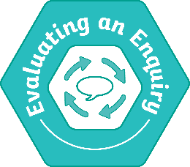
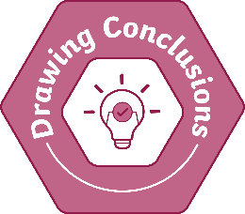
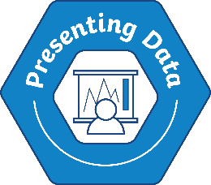
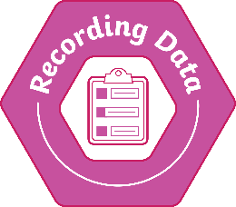
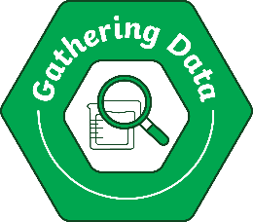
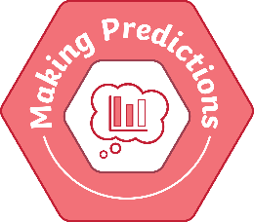
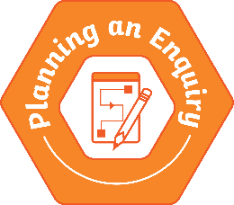


PlanIt Science has identified eight key skills of working scientifically. These are:
- Asking Questions
- Planning an Enquiry (key stage 2 only)
- Making Predictions (key stage 2 only)
- Gathering Data
- Recording Data
- Presenting Data (key stage 2 only)
- Drawing Conclusions
- Evaluating an Enquiry (key stage 2 only)
We have taken the working scientifically aims from the national curriculum as well as the working scientifically skills above and made a clear breakdown of progression statements that show progression and enable children to meet the national curriculum aims. These statements have been organised based on the eight key skills, cover the statutory statements and also use the non-statutory national curriculum guidance. They have been written with consideration for children’s progression through the English and mathematics programmes of study. These statements are mapped out on the PlanIt Science Progression Map Year 1–6 Spreadsheet, where they are linked to each PlanIt lesson. You will also see these statements reflected in the working scientifically assessment statements found on our lesson plans and assessment spreadsheets.
Although the skills of planning an enquiry, making predictions, presenting data and evaluating an enquiry have not been formally mapped across KS1, children will start to work on some of these skills through adult-led discussion and their natural exploration.
Working Scientifically Skills

Scientific enquiries are identified in lessons throughout the PlanIt content and these are highlighted in lessons – look out for these icons across our resources.
Scientific Enquiry
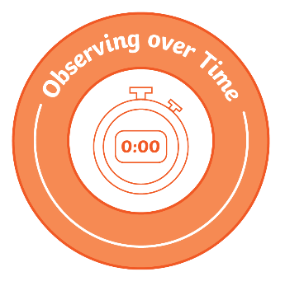

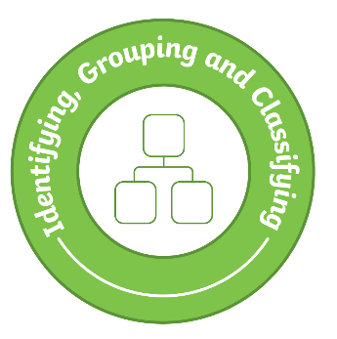
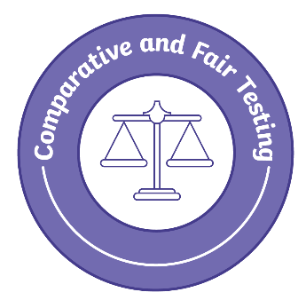


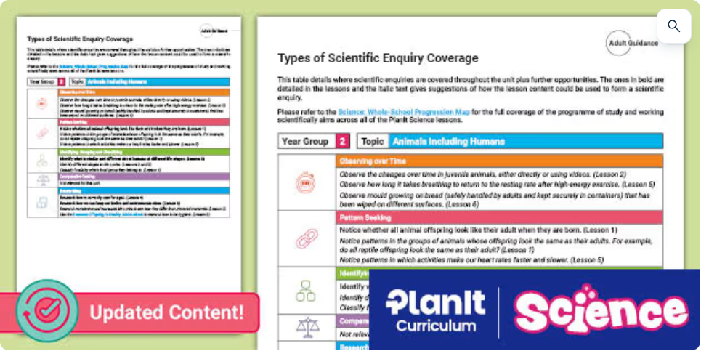
Types of Scientific Enquiry Coverage documents have been produced for each PlanIt unit. These detail the formal scientific enquiries that have been included in each unit, as well as a range of ideas of how the lesson content can also be used for other types of enquiry.

Through an investigative and enquiry-led approach, children learn to use a variety of different working scientifically skills to answer relevant scientific questions. The national curriculum states that KS1 and KS2 children should carry out these types of scientific enquiry: observing over time; pattern seeking; identifying, classifying and grouping; comparative and fair testing (controlled investigations); and researching using secondary sources. The PlanIt Science Progression Map Year 1–6 Spreadsheet shows where each enquiry type has been included across the PlanIt scheme. Further scientific enquiry resources can be found for KS1 here and KS2 here.

PlanIt Science Working Scientifically Skills Progression Map

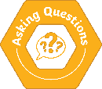 | Asking Questions
 | KS1 |  | LKS2 |  | UKS2
 | NC: asking simple questions and recognising that they can be answered in different ways |  | NC: asking relevant questions and using different types of scientific enquiries to answer them  using results to draw simple conclusions, make predictions for new values, suggest improvements and raise further questions |  | NC: planning different types of scientific enquiries to answer questions, including recognising and controlling variables where necessary  using test results to make predictions to set up further comparative and fair tests
 | Year 1 | Year 2 | Year 3 | Year 4 | Year 5 | Year 6
 | ask some simple scientific questions (using provided question stems) when exploring objects, living things and processes  based on modelled examples, begin to recognise how to ask their own simple questions about a given scenario, using correct vocabulary | ask simple scientific questions (using a range of provided question stems) when exploring objects, living things and processes  with support, construct a simple question based on a given scenario, using correct vocabulary | with support, begin to ask their own scientific enquiry questions using a given question starter  through group discussions and using scientific enquiry findings, begin to raise further questions that could be investigated | ask their own scientific enquiry questions using a given question starter  using scientific enquiry findings, raise further questions that could be investigated | independently generate scientific enquiry questions based on initial observations or research | independently generate scientific enquiry questions based on initial observations or research that reflect different scientific enquiry types

PlanIt Science Working Scientifically Skills Progression Map

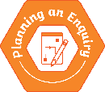 | Planning an Enquiry
 | KS1 |  | LKS2 |  | UKS2
 |  |  | NC: asking relevant questions and using different types of scientific enquiries to answer them  setting up simple practical enquiries, comparative and fair tests |  | NC: planning different types of scientific enquiries to answer questions, including recognising and controlling variables where necessary  using test results to make predictions to set up further comparative and fair tests
 | Year 1 | Year 2 | Year 3 | Year 4 | Year 5 | Year 6
 |  |  | start to make their own decisions about the most appropriate type of scientific enquiry they might use to answer questions  with support, begin to recognise what data (e.g. observations or measurements) needs to be collected to answer an enquiry question  help to decide the most appropriate equipment needed to carry out an enquiry  help to decide how to record data (e.g. how long they will make their observations and measurements for) | suggest the most appropriate type of scientific enquiry they might use to answer questions, making connections with previous enquiries  begin to make independent decisions about what data (e.g. observations or measurements) needs to be collected to answer an enquiry question  begin to decide the most appropriate equipment needed to carry out an enquiry, giving reasons for their choices  begin to make decisions on how to record data (e.g. how long they will make their observations and measurements for), giving reasons for their choices | with guidance, begin to plan their own method to answer a scientific enquiry question, including (where appropriate) what equipment to use, how to gather the data required and identifying variables | plan their own method to answer a scientific enquiry question, including (where appropriate) what equipment to use, how to gather the data required and identifying variables

PlanIt Science Working Scientifically Skills Progression Map

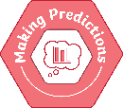 | Making Predictions
 | KS1 |  | LKS2 |  | UKS2
 |  |  | NC: using results to draw simple conclusions, make predictions for new values, suggest improvements and raise further questions |  | NC: using test results to make predictions to set up further comparative and fair tests
 | Year 1 | Year 2 | Year 3 | Year 4 | Year 5 | Year 6
 |  |  | begin to identify simple patterns in data gathered to make predictions for the next value  begin to use provided relevant conceptual scientific knowledge to make predictions | identify simple patterns in data gathered to make predictions for the next value, giving reasons for their predictions  begin to use prior scientific knowledge and understanding, along with provided relevant conceptual knowledge, to make predictions | notice simple patterns in data gathered and use this to suggest predictions for further values  begin to use scientific understanding acquired through previous scientific enquiries, along with provided relevant conceptual knowledge, to make predictions and plan future comparative and fair tests | use patterns in data gathered to make justified predictions for further values  use scientific knowledge and understanding acquired through previous scientific enquiries to make predictions and plan future comparative and fair tests

PlanIt Science Working Scientifically Skills Progression Map

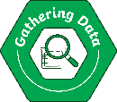 | Gathering Data
 | KS1 |  | LKS2 |  | UKS2
 | NC: observing closely, using simple equipment  performing simple tests  gathering and recording data to help in answering questions |  | NC: making systematic and careful observations and, where appropriate, taking accurate measurements using standard units, using a range of equipment, including thermometers and data loggers  gathering, recording, classifying and presenting data in a variety of ways to help in answering questions |  | NC: taking measurements, using a range of scientific equipment, with increasing accuracy and precision, taking repeat readings when appropriate
 | Year 1 | Year 2 | Year 3 | Year 4 | Year 5 | Year 6
 | share observations about objects, materials and living things, using appropriate vocabulary selected from supporting resources  identify similarities and differences between objects, materials and living things, using appropriate vocabulary selected from supporting resources  describe and share simple changes that have been observed over time  with support, use equipment, such as a magnifying glass or microscope, correctly when making observations  make direct comparisons of measurements, such as length and height  take measurements of length or height in non-standard units  begin to use simple equipment, such as rulers, teaspoons and pipettes, to take measurements  with support, begin to use simple secondary sources for researching answers to questions, recording findings in a variety of ways | share observations about objects, materials and living things, using correct scientific vocabulary with increasing confidence  use equipment, such as a magnifying glass or microscope, correctly when making observations  identify similarities and differences between objects, materials and living things, using correct scientific vocabulary with increasing confidence  describe and share simple changes that have been observed over time, using correct scientific vocabulary with increasing confidence  use equipment, such as a magnifying glass or microscope, correctly make comparisons of measurements, both directly and from data collected  take measurements of length or height in non-standard units, making decisions on the equipment (e.g. bricks, lolly sticks, paper strips) that would be most appropriate to use  use simple equipment, such as rulers, teaspoons and pipettes, to take measurements with increasing confidence  use simple secondary sources for researching answers to questions, recording findings in a variety of ways | begin to make systematic and careful observations  begin to accurately measure time in standard units using stopwatches or timers  begin to accurately measure length or height in standard units using equipment such as rulers or tape measures  begin to recognise when it might be appropriate to use a sensor device, such as a data logger, to take precise measurements, e.g. recording data over a long period of time  begin to use sensors/sensor devices, such as data loggers, to take measurements (e.g. light and sound) | make systematic and careful observations  accurately measure time in standard units using stopwatches or timers  accurately measure length or height in standard units using equipment such as rulers or tape measures  accurately measure temperature in standard units, using a thermometer correctly  accurately measure capacity in standard units, using equipment such as syringes or beakers correctly  begin to use sensors/sensor devices, such as data loggers, to take measurements (e.g. light and sound) | make systematic, careful and detailed observations, recording them using a given format  use a range of equipment to take measurements in standard units with increasing precision  from a selection, choose the most appropriate measuring equipment to use in order to give precise results  begin to recognise when it might be appropriate to use a sensor device, such as a data logger, to  take precise measurements, e.g. recording data over a long period of time  take repeat readings where appropriate and understand the importance of this | make systematic, careful and detailed observations, selecting an appropriate format to record their observations  use a range of equipment to take measurements in standard units with increasing precision, recognising when they might need to give the measurement in mixed units or using decimals  name the most appropriate measuring equipment to use in order to give precise results  recognise when it might be appropriate to use a sensor device, such as a data logger, to take precise measurements, e.g. recording data over a long period of time  recognise when it is or is not appropriate to take repeat readings, giving reasons for their decisions

PlanIt Science Working Scientifically Skills Progression Map

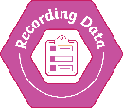 | Recording Data
 | KS1 |  | LKS2 |  | UKS2
 | NC: performing simple tests  gathering and recording data to help in answering questions  identifying and classifying |  | NC: gathering, recording, classifying and presenting data in a variety of ways to help in answering questions  recording findings using simple scientific language, drawings, labelled diagrams, keys, bar charts, and tables |  | NC: recording data and results of increasing complexity using scientific diagrams and labels, classification keys, tables, scatter graphs, bar and line graphs
 | Year 1 | Year 2 | Year 3 | Year 4 | Year 5 | Year 6
 | with support, begin to record observations with a camera, using photos or videos to support identification  begin to produce accurate drawings to document observations  with support, begin to produce labelled drawings to document observations  with support, begin to use scientific vocabulary accurately when writing about observations or comparisons, and read and spell some of these words at a level consistent with their word reading and spelling knowledge  physically sort and classify objects, materials or living things into simple groups by a given criterion  based on findings from testing, begin to physically classify objects or materials into groups by a given criterion  begin to use findings from tests to physically rank objects or materials  record their findings in a scaffolded table or use hoops/circles to sort data or objects | record observations with a camera, using photos or videos to support identification  produce increasingly accurate drawings to document observations  produce accurately labelled drawings to document observations  with support, use a range of scientific vocabulary accurately when writing about observations or comparisons, and read and spell some of these words at a level consistent with their word reading and spelling knowledge  physically sort and classify objects, materials or living things into simple groups, choosing appropriate criteria from suggested options  based on findings from testing, physically classify objects or materials into groups, beginning to choose their own criteria for sorting  use findings from tests to physically rank objects or materials  record their findings in a partially scaffolded sorting table or simple Venn diagram (sorting rings)  gather and record findings using a scaffolded pictogram  gather and record findings using a tally chart  gather and record findings using a physical block diagram | complete a simple prepared table to record data such as measurements, observations or research findings  with support, use a partially scaffolded complex table to record findings  with support, begin to add data onto a bar chart with the labels, axes and scales provided  produce accurate drawings and labelled diagrams to record observations and present information  record findings from supported research tasks using a template and present findings in a variety of ways | construct a simple table to record data such as measurements, observations or research findings  use a partially scaffolded complex table to record findings  record data onto a bar chart with the labels, axes and scales provided  produce accurate drawings and labelled diagrams to record observations and present information, incorporating the use of a key when necessary  locate the information needed to answer questions during research tasks and record findings in a variety of ways | decide how to record data from a choice of familiar methods, e.g. labelled diagrams, tables or keys  with guidance, construct a complex table to record data in  with guidance, construct and record data in a bar chart, identifying appropriate scales and variables for each axis and labelling them correctly, including units  with support, record data in a line graph, using a given template to plot points and adding an appropriate line  with guidance, use a pre-populated scatter graph to interpret the relationship between 2 variables  record classification tasks in a variety of ways, e.g. using classification keys or Carroll diagrams  decide how to record findings from their research in a variety of ways, recognising the difference between fact and opinion | efficiently record data using a chosen familiar method, e.g. labelled diagrams, tables or keys  independently construct a complex table to record data in  construct and record data in a bar chart, identifying appropriate scales and variables for each axis and labelling them correctly, including units  construct and record data in a line graph, labelling each axis with suitable variables, scales and units, plotting points accurately and adding an appropriate line  with increasing confidence, use a pre-populated scatter graph to interpret the relationship between 2 variables, identifying any anomalous data  present data and results using simple scatter graphs with the axes and scales provided  record classification tasks of increasing complexity, e.g. using classification keys or Carroll diagrams  decide how to record findings of increasing complexity from their research in a variety of ways, choosing which sources are the most reliable and useful and giving reasons for this

PlanIt Science Working Scientifically Skills Progression Map

 | Presenting Data
 | KS1 |  | LKS2 |  | UKS2
 |  |  | NC: gathering, recording, classifying and presenting data in a variety of ways to help in answering questions  recording findings using simple scientific language, drawings, labelled diagrams, keys, bar charts, and tables  reporting on findings from enquiries, including oral and written explanations, displays or presentations of results and conclusions |  | NC: reporting and presenting findings from enquiries, including conclusions, causal relationships and explanations of and a degree of trust in results, in oral and written forms such as displays and other presentations
 | Year 1 | Year 2 | Year 3 | Year 4 | Year 5 | Year 6
 |  |  | with support, present information that classifies living and non-living things, e.g. using tables or Venn diagrams  with a provided template, present collected data in a different way to help answer a scientific question | present information that classifies living and non-living things, e.g. using simple classification keys or Venn diagrams  with increasing independence, present collected data in a different way to help answer a scientific question | using a given structure, report and present their results and conclusions to others in a variety of ways, including oral and written forms  with some guidance, present collected data in a different way using a familiar method (e.g. ranking data or on a graph) to help answer a scientific question | choose the most appropriate method (e.g. oral or written) to report and present their results and conclusions to others, giving reasons for their choices  choose how to present collected data in a different way using a familiar method (e.g. ranking data or on a graph) to help answer a scientific question

PlanIt Science Working Scientifically Skills Progression Map

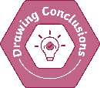 | Drawing Conclusions
 | KS1 |  | LKS2 |  | UKS2
 | NC: asking simple questions and recognising that they can be answered in different ways  identifying and classifying  using their observations and ideas to suggest answers to questions |  | NC: reporting on findings from enquiries, including oral and written explanations, displays or presentations of results and conclusions  identifying differences, similarities or changes related to simple scientific ideas and processes  using straightforward scientific evidence to answer questions or to support their findings  using results to draw simple conclusions, make predictions for new values, suggest improvements and raise further questions |  | NC: reporting and presenting findings from enquiries, including conclusions, causal relationships and explanations of and a degree of trust in results, in oral and written forms such as displays and other presentations  identifying scientific evidence that has been used to support or refute ideas or arguments
 | Year 1 | Year 2 | Year 3 | Year 4 | Year 5 | Year 6
 | start to become familiar with different types of scientific enquiry and recognise how they can be used to answer questions  name some living and non-living things using observations and simple secondary sources, beginning to justify how they identified these things  begin to use data to make comparisons in their conclusions (using vocabulary such as biggest and smallest)  with support, use data gathered (measurements, observations or research) to answer a scientific question  with support, begin to notice simple patterns and relationships in data and observations gathered | name different types of scientific enquiry that they have carried out and recognise how they can be used to answer questions  name living and non-living things using observations and simple secondary sources (e.g. identification sheets), justifying how they identified these things  use data to make comparisons in their conclusions (using vocabulary such as biggest and smallest)  use data gathered (measurements, observations or research) to answer a scientific question  begin to notice simple patterns and relationships in data and observations gathered | begin to use correct scientific vocabulary to communicate findings from practical activities, e.g. in written or verbal explanations  with support, use findings and evidence from scientific enquiries to answer questions and support their conclusions  with support, begin to identify simple changes, patterns or similarities and differences in data, observations or research to help answer questions and draw conclusions | use correct scientific vocabulary to communicate findings from practical activities, e.g. in written or verbal explanations  use findings and evidence from scientific enquiries to answer questions and support their conclusions  with support, identify changes, patterns or similarities and differences in data, observations or research to help answer questions and draw conclusions | use correct scientific vocabulary and evidence from data gathered, such as identified patterns, when making a conclusion to answer a scientific enquiry question  begin to recognise and discuss the degree of trust they can have in a set of results, for example by comparing results with other groups or with their own scientific understanding  with support, begin to analyse results to determine and then explain simple causal relationships  begin to discuss how data they have gathered may have changed their initial scientific ideas  find out, from given sources of information, how scientific understanding is continually changing over time, with reference to scientific evidence that has been used to support or refute ideas | use correct scientific vocabulary and evidence from data gathered, such as identified patterns, when making an in-depth conclusion to answer a scientific enquiry question  recognise and discuss the degree of trust they can have in a set of results, for example by comparing results with other groups or with their own scientific understanding  analyse results to determine and then explain causal relationships  discuss how data they have gathered may have changed their initial scientific ideas, identifying whether data supports or refutes their predictions  develop their knowledge further of how scientific understanding is continually changing over time, with reference to scientific evidence that has been used to support or refute ideas

PlanIt Science Working Scientifically Skills Progression Map

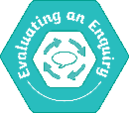 | Evaluating an Enquiry
 | KS1 |  | LKS2 |  | UKS2
 |  |  | NC: using results to draw simple conclusions, make predictions for new values, suggest improvements and raise further questions |  | NC: reporting and presenting findings from enquiries, including conclusions, causal relationships and explanations of and a degree of trust in results, in oral and written forms such as displays and other presentations
 | Year 1 | Year 2 | Year 3 | Year 4 | Year 5 | Year 6
 |  |  | begin to suggest and explain simple improvements to investigations, such as changes they could make to their method  with guidance, compare more than one method for a test and suggest which one gives better results | suggest and explain simple improvements to investigations, such as changes they could make to their method  compare more than one method for a test and suggest which one gives better results, giving reasons for their opinion | begin to establish the degree of trust they can have in a set of results by considering the precision of their measurements  begin to evaluate the degree of trust they can have in a set of results to answer a question by considering enquiry limitations and how variables were controlled in order to give sufficient data | establish the degree of trust they can have in a set of results by considering the precision of their measurements  evaluate the degree of trust they can have in a set of results to answer a question by considering enquiry limitations and how variables were controlled in order to give sufficient data

The editable PlanIt Science Progression Map Year 1–6 Spreadsheet is separated into a tab for each year group. This first section maps the national curriculum programme of study aims (the substantive knowledge):
PlanIt Science Progression Map Year 1–6 Spreadsheet
Lesson Numbers
When shaded, these numbers identify which lessons in the unit build upon the national curriculum aim.
National Curriculum Aims
The aims are taken directly from the national curriculum.
PlanIt Units
Each unit title is hyperlinked to our range of PlanIt resources, which include everything you need to teach each unit and meet the national curriculum aims.

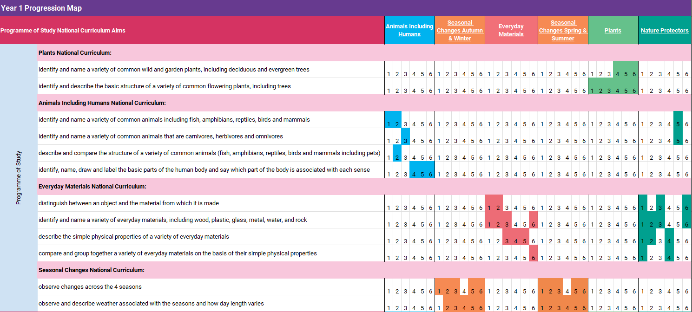

This section of each year group’s tab maps the working scientifically objectives (the disciplinary knowledge). The national curriculum objectives have been broken down into progression statements. Each statement is aligned with a different working scientifically skill.
PlanIt Science Progression Map Year 1–6 Spreadsheet
National Curriculum Aims
National curriculum statutory working scientifically aims are provided here for reference.
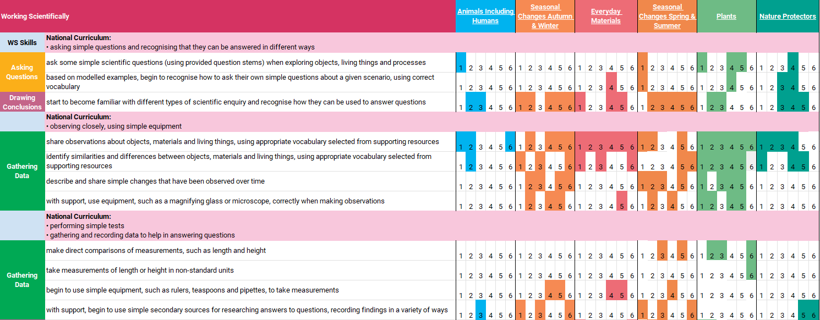

Lesson Numbers
When shaded, these numbers identify which lessons in the unit build upon the working scientifically progression statements.
Progression Statements
These progression statements have been written specifically to show progression across the year groups. They reflect what learning should look like in specific year groups in order to meet end-of-key-stage working scientifically aims. Statements written in italic font are those that relate to multiple national curriculum aims and are repeated.
Working Scientifically Skills
The working scientifically skills are shown here, adjacent to the progression statements.

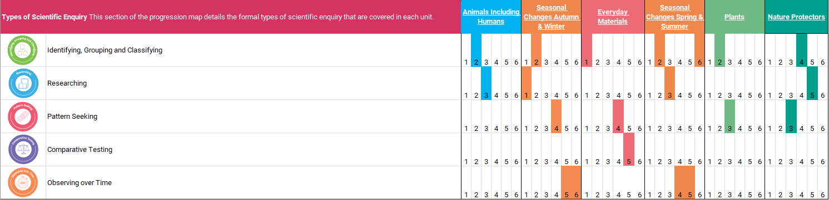
Lesson Numbers
When shaded, these numbers identify which lessons in the unit include a formal scientific enquiry.
Types of Scientific Enquiry
This list shows the five types of scientific enquiry explicitly taught in the PlanIt Science scheme of learning. Not every lesson has a formal scientific enquiry. There is a range of scientific enquiries, practical activities and discrete learning opportunities across the scheme.
Finally, the last section of the spreadsheet identifies where in a unit formal scientific enquiries have been included.
PlanIt Science Progression Map Year 1–6 Spreadsheet

