Health and Wellbeing

Theme | KS1 | LKS2 | UKS2
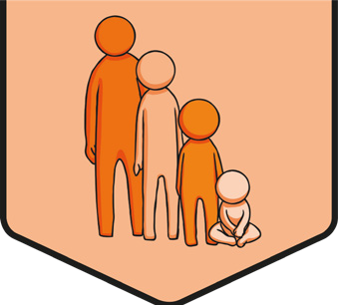  Safety First | 999, burn, chemicals, choke, danger, e-Safety, emergency, emergency services, fall, fire, harm, hazard, help, hurt, Internet, liquids, medicines, online, poisonous, protect, rail, risk, road, rules, safe, sharp, stranger, safer stranger, tablets, traffic, trip, trusted adult, uniform, unsafe, water | addictive, alcohol, ambulance, casualty, choices, cigarettes, comfortable, cycling, dangerous, dare, depth, drugs, e-cigarettes, electricity, first aid, first-aider, graze, impact, independent, inhaler, injection, injury, instructions, lungs, medicines, nicotine, paramedic, peer pressure, physical, right, road safety, safety, scald, shock, uncomfortable, vaccine, vaping, water safety, wellbeing | accident, action, advice, brave, consequence, decision, environment, independence, informed, liquids, mature, media, medication, pills, responsible, sensible, situation, social media, support, unfamiliar
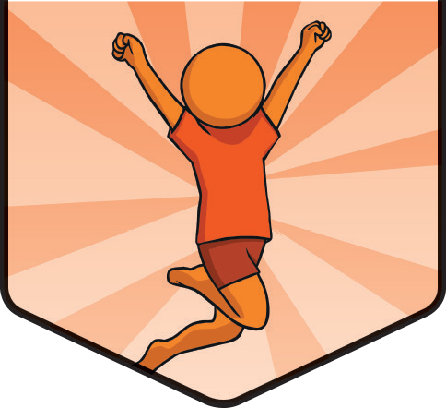  It’s My Body | bacteria, body, brain, brushing, chemicals, chemist, choice, clean, colds, consent, contact, coughs, danger, dentist, diarrhoea, diet, disease, doctor, emergency, exercise, fluoride, germs, healthy, heart, help, illness, medicine, mind, muscles, permission, pharmacist, poisonous, protect, rest, rules, safe, secret, serious, sleep, spread, strength, sugar, surprise, touch, treat, uncomfortable, unhealthy, unsafe, virus, warning, wash | addiction, alcohol, allergies, balanced, bedtime, caffeine, Childline, cigarettes, consent, consequence, contagious, decision, dietary, drugs, e-cigarettes, habit, harmful, health, heart rate, hormones, hydrated, hygiene, illegal, immunisation, independence, infection, legal, nicotine, prescription, relax, resilience, restricted, routine, sleep hygiene, tobacco, vaccinations, vaping, vitamins | addictive, advertising, age restrictions, appearance, appropriate, autonomy, balanced lifestyle, beauty, boundaries, care, cleanliness, contact, control, damage, dangerous, dental, deprivation, effects, emotional, healthy eating, impact, influence, looks, media, meditation, mental, mindfulness, negative, oral, perfect, physical, platform, positive, pressure, protect, respect, responsibility, rest, rights, self-confidence, stereotype, substances, sun exposure, support, tell, unwanted, vape pens, vapes, wellbeing
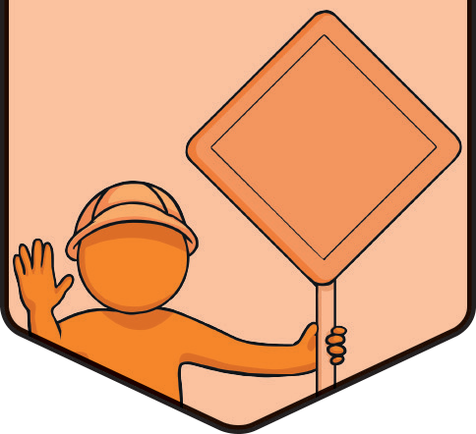  Think Positive | achievement, angry, bored, calm, choice, complain, concentrate, confused, decision, difficult, dislike, embarrassed, emotions, fears, fed up, feelings, focus, frightened, frustrated, future, goal, gratitude, happy, healthy, helpful, like, lonely, mind, mindful, negative, nervous, new, past, perseverance, positive, prefer, relaxed, resilience, respond, rest, sad, safe, shocked, thankful, thinking, thoughts, unhelpful, upset, worries | anger, anxious, attitude, aware, brain, brave, breathing, challenge, changes, chemicals, consequences, control, curious, determination, different, distract, dopamine, effort, embarrassment, endorphins, exciting, experience, failure, flexible, grief, guilt, happiness, jealousy, joy, mental health, mindfulness, mistakes, oxytocin, peace, perseverance, practise, prepare, problem, relax, represent, sadness, serotonin, shame, strategies, strengths, success, techniques, uncomfortable, unpleasant, weaknesses, worry | actions, affect, behaviour, blame, cognitive, comfortable, coping, difficulties, impact, independent, influence, learning, link, mindset, morals, opportunities, progress, pros and cons, reaction, responsible, strategy
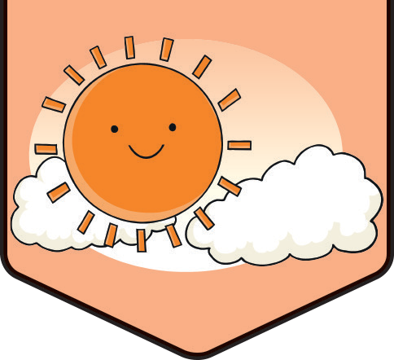  Growing Up | adulthood, advice, carers, caring, change, childhood, comfortable, consent, coping, curious, develop, differences, difficult, emotions, female, genitals, grandparents, independence, love, male, needs, nipples, opportunities, parents, penis, private parts, respect, responsibility, rules, safe, siblings, similarities, stereotype, testicles, touch, traditions, trusted adult, uncomfortable, unique, vagina, vulva, worried | adopted, Adam’s apple, anger, anxious, attracted, baby, biological sex, blended family, breasts, commitment, confusion, crush, egg, embryo, erection, excited, feelings, foetus, fostered, gender, hormones, identity, lonely, married, menstruation, oestrogen, offspring, ovaries, period, puberty, relatives, reproduction, single-parent, sperm, tearful, testes, testosterone, umbilical cord, uterus, womb | acne, amniotic fluid, amniotic sac, birth, body image, body odour, caesarean section (C-section), choice, conceive, conception, consent, discharge, fancy, heterosexual, illegal, legal, media, mood swings, negative, placenta, self-esteem, sex, sexual, sexual intercourse, stressed, vaginal birth, weight, wet dreams, zygote

Relationships

Theme | KS1 | LKS2 | UKS2
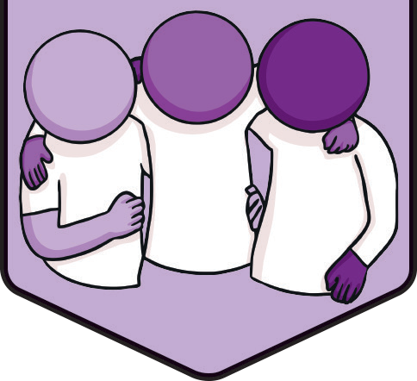  TEAM | active listening, assertive, behaviour, bullying, care, choices, community, compliment, controlling, discussion, fair, family, friends, group, helpful, joking, kind, learner, mindset, needed, negative, polite, positive, safe, secure, special, support, team, teasing, thoughtful, unkind | achieve, actions, attitude, behaviours, benefit, body language, change, collaboratively, communication, compromise, conflict, consequences, considerate, dispute, effect, emotion, facial expression, feelings, goals, impact, individuals, interpret, listening, negotiation, reflect, resolution, resolve, responding, responsibility, teammates, teamwork, transition, unhelpful | admire, attributes, collaborate, collaboration, communicate, contribute, decisions, disagree, discrimination, effective, emotional, excluding, harassment, health, honesty, hurtful, kindness, opinion, outcome, patience, respectful, sensitive, skills, social media, success, successful, thoughts, trolling, uncomfortable, understanding, upsetting, valued
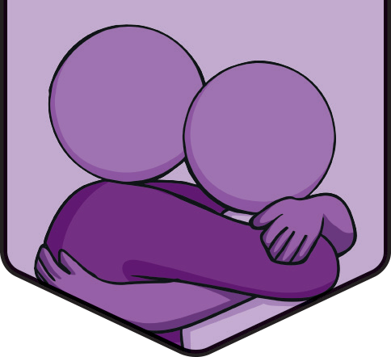  VIPs | achieve, boundaries, caring, choices, conflict, cooperate, cooperation, disagreement, family, friend, friendship, group, happy, healthy, help, important, kind, listen, love, making up, need, positive, safe, share, skills, solve, sort, special, support, talk, team, thoughtful, time, trust, trusted adult | acquaintances, actions, alternatives, anonymous, anti-bullying, arguments, assertive, behaviour, bully, bullying, compromise, consequences, consideration, controlling, cyber, dares, decisions, differences, discrimination, disputes, diversity, equality, equity, falling out, honest, impact, interests, kindness, loyal, negotiation, opinions, prejudice, prejudiced, reflect, relatives, resolving, respect, strategies, support, network, teasing, techniques, thought, unhealthy, victim, views, VIPs | advice, agree, anxious, blended families, commitment, committed, confidence, confidential, dangerous, family life, family structure, influence, living apart, living together, peer, polite, pressure, relationship, resist, resolution, risky, same-sex parents, secrets, security, self-love, single parents, stability, uncomfortable, wrong
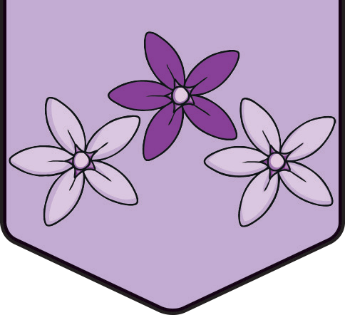  Be Yourself | angry, assertive, body language, calm, change, confidence, content, controlling, cross, disagree, wellbeing, emotions, enjoy, excited, facial expressions, feelings, happiness, happy, help, interests, kind, like, loss, memories, mental health, nervous, opinions, qualities, sad, safe, secure, share, skills, speak, talents, talk, thoughts, uncomfortable, unhappy, worried | achievements, actions, advertisements, comfortable, confident, consequences, dares, effects, emotional, forceful, gloating, hide, impact, influence, manipulated, mind, mistake, positive, pressure, pride, pushy, resist, resolution, resolve, right, rude, scared, sorry, strategies, strengths, support | acceptance, alternatives, amends, anxious, apologise, bereavement, caring, celebrate, choices, communication, conflict, danger, dangerous, death, difficulties, express, face-to-face relationships, failure, feelings, generosity, grief, guilt, individual, individuality, intensity, kindness, loyalty, manage, negative, online friendships, options, peer approval, peer influence, peer pressure, perceived failure, problems, relationships, respect, setbacks, sharing, shy, trust, truthfulness, unhealthy, unhelpful thoughts, unique, uniqueness, wrong
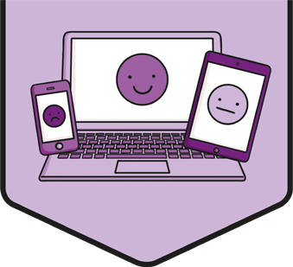  Digital Wellbeing | access, activity, address, apps, comfortable, communicate, connected, device, download, electronic, emoji, fact, fake, healthy, helpful, hobbies, information, interests, Internet, lie, mental wellbeing, message, messaging, network, news, offline, online, password, personal information, picture message, pretend, private, screen time, sleep, social media, surname, text message, true, trusted adult, uncomfortable, video call | addiction, balance, behaviour, bullying, communicating online, concerns, connected devices, consequences, cyberbullying, discrimination, disrespect, face-to-face, forward, fraud, gaming, harassment, harmful content, images, impact, in-app spending, information sharing, in-game spending, manipulated, misinformation, name-calling, permission, positive, privacy, ranking, relationships, reliability, report, respect, restrictions, risks, rules, safety, scams, search results, share, shared information, social media, support, targeted information, teasing, text, trolling, videos | appropriate, assess, benefit, boundaries, choices, consent, contact, content, control, data, deceive, digital, digital citizenship, digital footprint, digital health, digital wellbeing, echo chambers, emotional wellbeing, evaluate, excluding, false profiles, feelings, friendship, frightened, harassment, harmful, healthy, help, hurtful behaviour, image distribution, impersonate, inappropriate, intention, Internet cookies, kindness, manipulation, mental health, misleading, negative, online games, online identity, online safety, online strangers, personal safety, pressure, privacy settings, regulations, reliable, reputable, respectful, right, secure sites, selection, shared responsibility, sharing, sources, storage, targeting, time management, trust, wellbeing, worry

Living in the Wider World

Theme | KS1 | LKS2 | UKS2
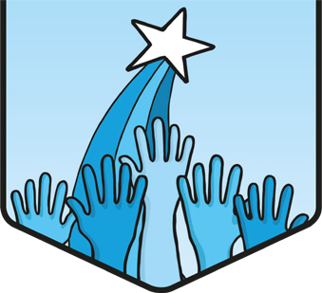  Aiming High | achievement, aims, ambition, attitude, change, communication, creative, determined, future, goal, grow, happiness, hard-working, help, improve, job, learn, positive, progress, qualification, routine, skill, star qualities, strength, success, training | accomplish, action, attribute, background, behaviour, challenge, curriculum vitae/CV, determination, develop, effort, employer, equal, experience, fair, gender, growth mindset, misogyny, information, learning, obstacles, opportunities, race, resilience, responsibilities, role, setbacks, stereotype, strive, target | advertisement, apprenticeship, avoidance, barriers, behaviours, benefit, business, careers, collaborate, college, creativity, criteria, decisions, discrimination, employee, enterprise, failure, fear, feedback, focus, further education, helpful, ideas, individual, innovation, interests, law, listening, mistakes, panic, perseverance, prejudice, privilege, problem-solving, responsible, rights, self-worth, social class, stress, teamwork, unhelpful, university
  One World | affect, care, choice, difference, earth, environment, environmental, family life, happy, harm, help, home, important, learn, love, natural, needs, people, planet, problem, protect, resources, right, safe, same, school, similarity, special people, trust, world | actions, challenge, charity, citizen, climate change, communities, compassion, consequence, consider, decision, difference, dilemma, discuss, diverse, diversity, effects, empathy, fair, Fairtrade, farmer, gender, global, harmful, helpful, human right, impact, inequality, local, negative, opinion, organisation, positive, reason, reduce, respect, responsibility, rural, share, shared responsibility, stereotype, support, trade, unfair, urban | appreciate, aware, biodiversity, citizenship, conserve, drought, encourage, energy, future, global citizen, global warming, human right, manifesto, persuade, pledge, prevent, renewable, responsible, responsibly, save, sustainability, sustainable, use, waste, water
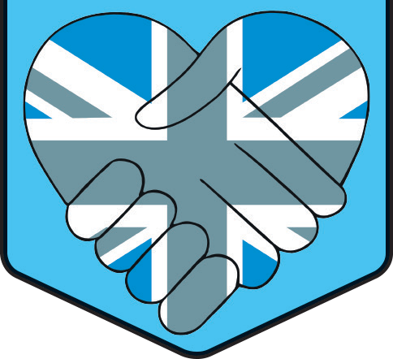  Diverse Britain | accepting, beliefs, belong, Britain, British, celebrations, choice, coast, community, countryside, difference, dress, environment, happy, harm, helpful, island, kindness, lakes, listen, live, local area, mountain, natural, neighbour, neighbourhood, proud, respect, responsibility, right, river, safe, same, share, similarity, town, United Kingdom | care, celebrate, challenge, citizen, common rights, concern, county, culture, customs, debate, democracy, discrimination, discuss, diverse, diversity, equality, ethnic, freedom, government, human rights, identity, liberty, multicultural, national, polite, prejudice, protect, region, regional, religious, rights-respecting, society, stereotype, tolerance, tradition, values | active citizenship, charity, community spirit, compassion, consequence, contribute, enforce, equal, ethnicity, faith, impact, laws, local government, members of parliament, national government, needs, negative, parliament, police, politicians, positive, prime minister, responsibilities, roles, shared responsibility, similar, support, voluntary
  Money Matters | advertising, amount, anxiety, bank, bank account, bills, borrow, budget, cash machine, choice, coins, contactless, date of birth, electronic, email address, emotions, employment, excitement, feelings, happiness, household, important, job, keep track, kindness, list, login, money, money box, notes, need, offers, online banking, online transfer, password, payment, personal information, personal situation, piggy bank, privacy, private, purse, record, receipt, repay, respect, sadness, safe, save, savings, smartphone, spend, spending, stress, trusted adults, username, value for money, wages, wallet, want, worry, work | advertise, benefits, cash, cash point, choices, contactless payment, cost, credit card, debit card, email, environment, ethical spending, expenses, gift, income, influence, online money transfer, online payment, payment methods, phishing, priorities, scam, smartphone payment, tax, text message, value | afford, banknotes, card reader, charity, comfortable, contribute, council tax, critical consumer, currency, decision, emotional wellbeing, fair trade, flexibility, in-app spending, income tax, in-game purchases, Internet, luxury, manufacturer, microtransactions, necessity, online, online money transfer, online shopping, outgoings, overdraft, passcode, pin code, plastic pollution, priorities, prioritise, qualities, qualifications, retailer, secure websites, single-use, society, uncomfortable

