Year 6  2025-26 | Autumn 1 | Autumn 2 | Spring 1 | Spring 2 | Summer 1 | Summer 2
Hook | The Amazon  Geography | Macbeth  Text | Wolf Brother  Text | The World at War  History | The World at War  History (cont’d) | Transition Project  The Highwayman
Writing | When I fell from the Sky  First person narrative  Diary entry  The Amazon Rainforest  Non-chronological report | The Murder of Duncan  Story with a Flashback  Newspaper report  Macbeth’s plan  Letter  Witches potions  Instructions | Wolf Brother  Monologue  Wolf Brother  Non-chronological report  Wolf Brother  Second person narrative | Preparing for War  Information Text  Burning the Books  Third Person Narrative  Battle of Britain  First Person Narrative | Operation Barbarossa  Letter writing  D-Day  Second person narrative  Hiroshima  Balanced Argument | Transition Project  Analysing text  The Highwayman  Letter writing  Diary entry
Reading – Core texts | 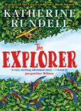  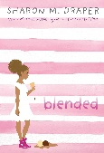 | 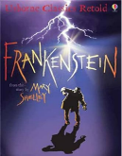  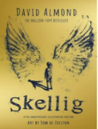 | 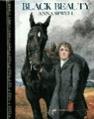  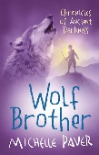 | 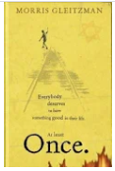  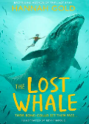 | 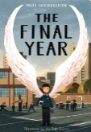  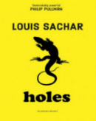 | 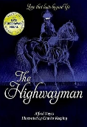
Maths | Place value  Four operations | Fractions, Decimals and Percentages | Ratio and Proportion  Interpreting Data  Area, Perimeter, Volume | Co-ordinates  Geometry  Time, Angles | Shape and Space  Algebra  Investigation Work | Transition work
Science | Living things and their habitats  Classification | The Human Body  Circulatory System and looking after ourselves |  | Evolution and Inheritance | Electricity  WW2 Morse Code
Geography | Physical  Rainforests | Physical  Mountains |  |  |  | Human and Physical  Oceans and plastic
Geography Fieldwork |  |  |  |  | House Hunting!
History |  |  | Crime and Punishment | The Mayan Civilisation | Local History Study  WW2
Art and Design Technology | Landscape Art  Amazon landscape | Creating Structures  Bird Houses | Sculpting  Vases | Cooking  Burgers | Express Yourself  Sketching portraits | Programming Pioneers
Computing | Online Safety | Film Making | Programming | Using and applying | Bletchley Park | Spreadsheets
Music | Happy  Singing skills | Classroom Jazz  Musical elements | A New Year Carol  Listening and appraising | You’ve got a Friend  Musical elements | Music and Me  Composing | Fleetwood Mac – Everywhere  Singing skills
PE | Invasion Games - Hockey Tactics  Outdoor and Adventurous Activities.  Gymnastics – Matching and Mirroring | Invasion Games  Hockey – Teamwork and formations  Gymnastics - Matching and mirroring | Net and Wall –Tennis. Develop individual shots  Dance – Visual Media | Striking and Fielding – Cricket  Gymnastics - Counter balance/counter tension | Athletics - Develop technical understanding of athletic activity.  Attacking and Defending Play | Athletics - Develop technical understanding of athletic activity.  Dance - Putting on a Performance
PSHE | Relationships | Health and Wellbeing | Living in the Wider World – Respecting Rights | Living in the Wider World – One World | Health and Wellbeing – Think Positive | Relationships – Growing Up
RE | What difference does it make to believe in Ahimsa (harmlessness), Grace (the generosity of God), and Ummah (community)? | How and why should religious communities do more to care for the Earth? | What matters most to  Christians and Humanists? | What can be done to reduce racism?  Can religion help? | What do religions say to us when life gets hard? | Is it better to express your religion in arts and architecture or in charity and generosity?
French | Around Town | Avez-vous un animal de compagnie? | Vêtement | à l’école | Le week-end
Enrichment  Experiences | Year 6 Boys Football  Food Bank  Cinema | Year 6 Boys Football  Young Shakespeare Company  Science Museum | School Journey |  | RAF Hendon

