Year 5  2025-26 | Autumn 1 | Autumn 2 | Spring 1 | Spring 2 | Summer 1 | Summer 2
Hook | Street Art | Kensuke’s Kingdom  Text | Vikings | Journey to Jo’burg  Text | The Lion, The Witch and the Wardrobe  Text | Robin Hood  Legends - Book
Writing | Balanced argument  Persuasive letter  Banksy fact file | Should Michael sail around the world?  Balanced Argument  Message in a Bottle  Informal letter  Orang-utan!  Alternative narrative  Michael meets Kensuke  Descriptive paragraph  Third person narrative  Alternative Ending  First Person Narrative | Alfred in the Marshes  Letter Writing  Thor and Loki  Third person narrative  The tale of Thor’s wedding  Diary Entry  The Battle of Hastings  Chronological Report | South Africa  Non-Chronological Report  Nelson Mandela  Biography  The Big Five!  Information Text  Save the Rhino!  Persuasive text  Shaka Zulu  Poetry | Through the Wardrobe  Diary Entry  The Other Side  Setting Descriptions  First Person Narrative  Edmund’s apology  Letter Writing  Should Edmund be Forgiven?  Balanced Argument | Robert of Huntingdon  Newspaper Report  Robin meets Little John  Third person Narrative  How to Make an Arrow  Instructions  Robin at the Archery Contest  Third person narrative
Reading – Core texts | 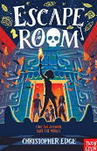  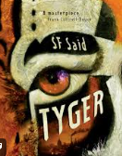 | 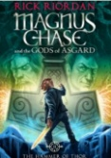  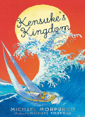 | 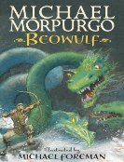  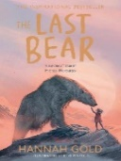 | 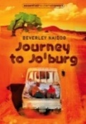  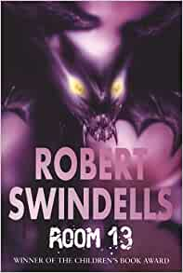 | 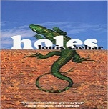  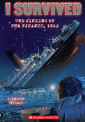 | 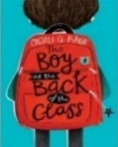  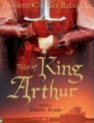
Maths | Place value  Four operations  (Using a range of measures) | Fractions, Decimals and Percentages  Money | Interpreting Data  Area and Perimeter | Co-ordinates  Geometry | Shape and Space  Time  Angles | Place value  Four operations  (Using a range of measures)
Science | Materials and their Properties | Forces | Earth and Space | Working Scientifically | Animals Including Humans
Geography |  | Physical  Rivers |  | Human and Physical  Europe and South Africa |  | Human and Physical  Marvellous Maps
Geography Fieldwork |  |  |  |  |  | Bird Watching!
History | Anglo Saxons |  | Vikings |  | Ancient Greeks
Art and Design Technology | Street Art | Fashion and Textiles | Chinese Art  Chinese New Year | Chinese Inventions | Frida Kahlo | Building Bridges
Computing | Online Safety | Multimedia | Espresso Coding |  | PowerPoint | Information Technology
Music | Livin’ on a Prayer  Singing skills | Classroom Jazz  Musical elements | Make you Feel my Love  Listening and appraising | The Fresh Prince of Bel-Air  Musical elements | Dancing in the Street  Composing
PE | Net/Wall Games  Developing individual shots  Dance  Formations in historical dance | Invasion Games Support play and formations  Gymnastics  Flight | Invasion Games  Support play and positioning  Gymnastics  Flight | Gymnastics  Bridges  (Back care)  Outdoor and Adventurous  Activities  Responding to challenges  (Benefits of being active) | Athletics - Develop technical understanding of athletic activity.  Attacking and Defending Play | Athletics - Develop technical understanding of athletic activity.  Dance - Putting on a Performance
PSHE | Relationships - Team | Health and Wellbeing -It’s my body | Living in the Wider World - Britain | Relationships – Be Yourself | Health and Wellbeing –Aiming High | Living in the Wider World – Money Matters
RE | Believing: What would Jesus do? (Can we live by the values of Jesus in the 21st century?) | Living: Green religion – What do religious and non-religious worldviews teach about caring for the Earth? (Part 1 – do first question + 2 religions) | Living: What does it mean to be a Muslim in Britain today? |  | Believing: Why do some people think God exists? | Expressing: If God is everywhere, why go to a place of worship?
French | Ma famille | La date | Quel temps fait-il ? | Avez-vous un animal de compagnie ? | Ma maison | En classe
Enrichment  Experiences | Cinema  The British Museum |  | Science Museum |  |  | St Andrew’s Church

Hrothgar and Beowulf
Dialogue
“I will kill your monster!”
Beowulf Battle Speech
The Battle With Grendel
Third Person Narrative
The Raid on Lindisfarne
Newspaper Report

