Year 4  2025-26 | Autumn 1 | Autumn 2 | Spring 1 | Spring 2 | Summer 1 | Summer 2
Hook | Iron Man  Text | Egyptology  Text | Romulus and Remus  Text | Fairy Tales  Text | Cheat!  Text | Oliver and the Seawigs  Text
Writing | Iron Man  Descriptive paragraph  Diary entry  Instructions  Newspaper report | Howard Carter’s Discovery!  Diary entry  The Great Pyramids  Information text  Isis and the Cobra  Third person narrative  Mummification  Instructional text | Romulus and Remus  Third person narrative  How to be a Roman Gladiator!  Instructions  Who were the Romans?  Information text  The Lost Happy Endings  Descriptive writing | Poetry  Haikus  Little Red Riding Hood  Playscript  Little Red Riding Hood  Narratives with an alternative ending  Little Red Riding Hood  Newspaper report | Cheat!  Letter writing  Playscript  Descriptive writing  Third person narrative | Oliver and the Seawigs  Character descriptions  Information leaflet  Living Things and their Habitats  Non-chronological report
Reading – Core texts | 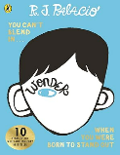  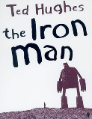 | 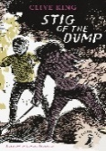  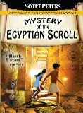 | 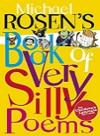  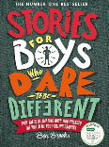 | 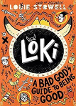  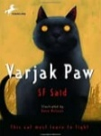 | 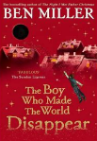  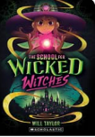 | 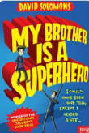  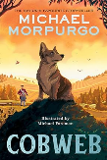
Maths | Place value  Addition and subtraction  (Using a range of measures) | Multiplication and division A  Measurement - area | Multiplication and division B  Length and perimeter | Fractions  Decimals A | Decimals B  Money  Time | Shape  Statistics  Position and direction
Science | Electricity | States of Matter | Sound | Animals including Humans | Scientific Discoveries | Living Things and their Habitats
Geography |  |  |  | Physical  Compass points and Grid references | Physical  Biomes | Human and Physical  Settlements
Geography Fieldwork |  |  |  |  |  | Outdoor PE venue hunt!
History | Indus Valley | Ancient Egyptians | Romans
Art and Design Technology | Plant Art | Seasonal Stockings | Sonia Delaunay | Seasonal Food | Recycled Art | Making Mini Greenhouses
Computing | Online Safety | Word Processing | Coding | Coding | Animation | Handling data
Music | Abba  Singing Skills | Glockenspiel 2  Musical Elements | STOP!  Listen and Appraise | Lean on Me  Listen and Appraise | Blackbird  Musical Elements
PE | Net/Wall Games -  Directing the ball. Table tennis - Ellenborough  Gymnastics - Balance | Dance - Communication  Invasion Games - Keeping possession of the ball. Handball/Tag rugby | Invasion Games -Controlling and receiving  Handball  Gymnastics - Receiving Body Weight | Striking and Fielding - How to hit or strike the ball into space, Fielding as a team. Rounders  Invasion Games -Marking and tackling. Handball | Athletics - Developing good running, throwing and jumping techniques  Outdoor and Adventurous Activity -  Follow map and symbol trails. Trust and communication activities (Residential trip) | Net/Wall Games -  Directing the ball. Table tennis - Ellenborough  Gymnastics - Balance
PSHE | Relationships - VIPs | Health and Wellbeing – Safety First | Living in the Wider World – Respecting Rights | Relationships  – Growing Up | Health and Wellbeing  – Think Positive | Living in the Wider World – One World
RE | Living:  What does it mean to be a Hindu in Britain today? | Living:  How do family life and festivals show what matters to Jewish people? | Living:  What can we learn from religions about deciding what is right and wrong? | Expressing:  Why are festivals important to religious communities?  (Part 2– do first & last question + 2 religions) | Expressing:  Why do some people think life is a journey? | Believing:  Why is Jesus inspiring to some people?
French | Me présenter | Ma famille | Goldilocks | En classe | Au salon de thé | Quel temps fait-il?
Enrichment  Experiences | Lego Workshop  Cinema |  | British Museum  London Archaeology & Ceramic Workshop (visitor) |  | Science Museum

