Year 3  2025-26 | Autumn 1 | Autumn 2 | Spring 1 | Spring 2 | Summer 1 | Summer 2
Hook | Charlie and the Chocolate Factory  Text | Ottoline  Text | The Sound Collector  Text | Alice in Wonderland  Text | Theseus and the Minotaur  Text | The Fastest Boy in the World  Text
Writing | Charlie and the Chocolate Factory  Descriptive paragraph  Character profiles  Third person narrative  Persuasive writing | Ottoline  Descriptive paragraph  Letter  Postcards | The Sound Collector  Poetry  Non-chronological reports | Alice in Wonderland  Setting description  Balanced arguments  Play scripts | Theseus and the Minotaur  First person narrative  Third person narrative  Comic strips | The Fastest Boy in the World  Third person narrative  Letter
Reading – Core texts | 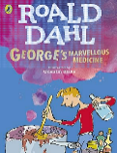  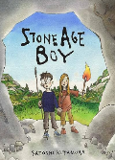 | 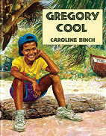  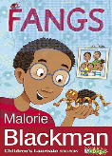 | 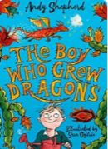  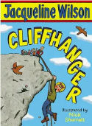 | 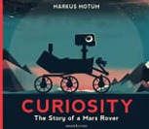  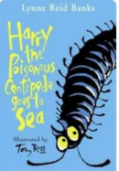 | 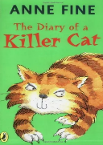  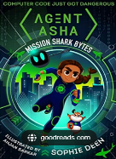 | 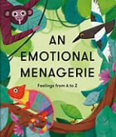  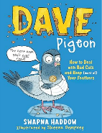
Maths | Place value  Addition and subtraction  (Using a range of measures) | Multiplication and division A | Multiplication and division B  Length and perimeter | Fractions A  Mass and Capacity | Fractions B  Money  Time | Shape  Statistics  Consolidation
Science | Rocks | Nutrition | Bones | Forces | Plants | Light and dark
Geography |  |  |  | Human and Physical  Location, Location, Location | Physical  Biomes | Human and Physical  Settlements
Geography Fieldwork |  |  |  |  | Outdoor PE venue hunt!
History | Stone Age | Bronze Age | Iron Age
Art and Design Technology | Plant Art | Seasonal Stockings | Sonia Delaunay | Seasonal Food | Recycled Art | Making Mini Greenhouses
Computing | Online Safety | Word Processing | Coding | Coding | Internet Research and Communication | Handling data
Music | Let your Spirit Fly  Singing Skills |  | Bob Marley  Three Little Birds |  | Bringing us Together  Musical Elements
PE | Net/Wall Games -  Developing game play Dance - Linking dance actions | Dance - Visual media  Invasion Games - Attacking and defending play | Gymnastics - Matching and mirroring  Invasion Games - Tactics | Invasion Games  Teamwork and formations  Dance  Putting on a dance  performance | Striking/fielding Games  Tactical play and officiating  Outdoor and Adventurous  Activities  Effective group working | Athletics x 2 - Developing technical understanding
PSHE | Relationships - Team | Health and Wellbeing -It’s my body | Living in the Wider World - Britain | Relationships – Be Yourself | Health and Wellbeing –Aiming High | Living in the Wider World – Money Matters
RE | Living: What does it mean to be a Christian in Britain today? | Expressing: Why are festivals important to religious communities? | Believing: Why is the Bible so important for Christians today? | Expressing: How do people from religious and non-religious communities celebrate key festivals? | Believing: What do different people believe about God? | Expressing:  Why do people pray?
French | I am Learning French | Animals | Instruments | I am able to | Vegetables | Ice cream
Enrichment  Experiences | Cinema |  | Natural History Museum |  | London Eye  River Cruise

